Don’t Hide Your Smile! Amazing Benefits of Clear Orthodontics

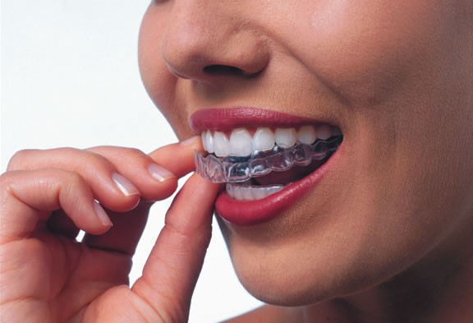
Dr.Nina Miteva as skilled orthodontist is performing amazing transformations on our patients smile. Whatever orthodontic issue the patient may be dealing with, there is a perfect dental treatment that could resolve it. Whether it is a crooked, crowded or rotated teeth - there is a perfect solution for your concerns.
The latest clear orthodontic treatment with clear aligners can bring amazing transformations to a patients smile as well as so many other benefits:
Enjoy a better looking smile. The most obvious benefit of undergoing a clear orthodontics procedure is being able to smile better. Your smile will be fantastic and people will surely notice.
Feel more confident about yourself. When one looks good, he almost automatically feels better about himself. Self-esteem and confidence is usually related to one’s appearance. When you look good, you feel so much better —as it is as if you gain extra power to do more and be more. Whether it is performing better in front of people or being more in control about yourself.
Improve your overall oral function. The teeth in the mouth holds various functions for mastication and nutrition, speech, maintenance of bite and facial integrity, as well as the health of the TMJ. Whatever functions are compromised, they may be restored and improved with the help of clear orthodontics.
Land more opportunities. You cannot deny this because this is true: many positions and job opportunities demand that an individual looks a certain way. Working on improving one’s smile eventually increases his chances of obtaining certain positions in a company or a specific industry.
When a patients come in for a clear orthodontics, “Dr. Nina Dental Clinic” will offer them different options based on the existing condition of their smile.
If you are yearning for a smile makeover, visit us http://www.drnina.mk/mk/ now to find out about your options.

Great Smile brings you Confidence

